LAB ASSIGNMENT 8: FLIGHTS AND BOOKINGS STUDIO3T ASSIGNMENT

COLLECTION 1: flights
Schema
{
flight_id: Number,
airline: String,
source: String,
destination: String,
price: Number,
duration: Number
}
Table
flight_id | airline | source | destination | price | duration
1 | Indigo | Delhi | Mumbai | 5000 | 2
2 | AirIndia | Kolkata | Chennai | 6500 | 3
3 | SpiceJet | Mumbai | Bangalore | 4000 | 1.5
4 | Vistara | Delhi | Chennai | 7000 | 3
5 | GoFirst | Mumbai | Delhi | 4800 | 2
6 | Indigo | Bangalore | Kolkata | 5500 | 2.5

COLLECTION 2: bookings
Schema
{
booking_id: Number,
passenger_name: String,
flight_id: Number,
city: String,
seats: Number,
total_fare: Number
}
Table
booking_id | passenger_name | flight_id | city | seats | total_fare
101 | Aarav | 1 | Delhi | 1 | 5000
102 | Meera | 2 | Kolkata | 2 | 13000
103 | Rohan | 3 | Mumbai | 1 | 4000
104 | Sneha | 4 | Delhi | 3 | 21000
105 | Kunal | 5 | Mumbai | 2 | 9600
106 | Priya | 6 | Bangalore | 1 | 5500

QUESTIONS

Q1. Display all flights.
Q2. Display passenger_name and city from bookings.
Q3. Find flights where source is Delhi.
Q4. Find bookings where seats = 1.
Q5. Sort flights by price in ascending order.
Q6. Display top 2 bookings with highest total_fare.
Q7. Find flights where price is greater than 5000.
Q8. Display flights where destination is not Chennai.
Q9. Find bookings where seats are between 1 and 2.
Q10. Update price by +500 for flights of airline "Indigo".
Q11. Delete bookings where seats are greater than 2.
Q12. Find total fare collected city-wise. (Aggregation)
Q13. Find average flight price per airline. (Aggregation)
Q14. Display airlines where average price is greater than 5500. (Aggregation + filter)
Q15. Find maximum total_fare among bookings for each city. (Aggregation)

ANSWER:
1.
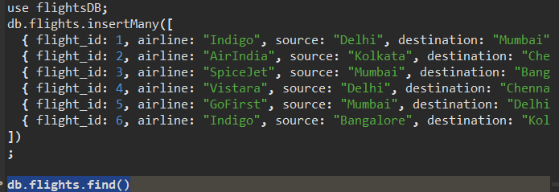
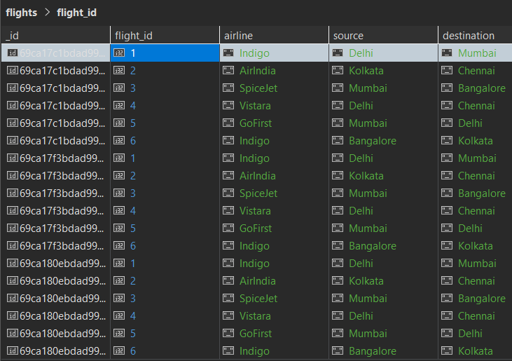
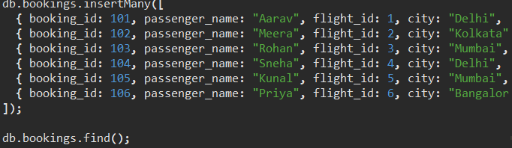
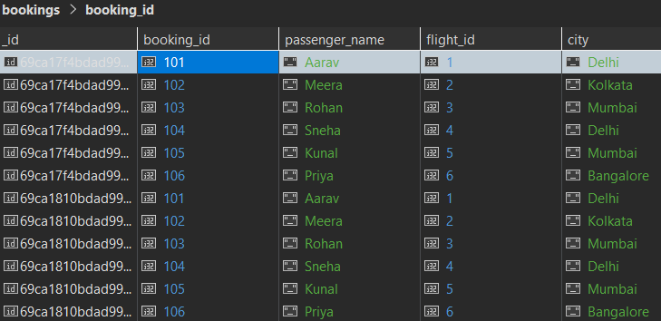
2.db.bookings.find({}, { passenger_name: 1, city: 1, _id: 0 });
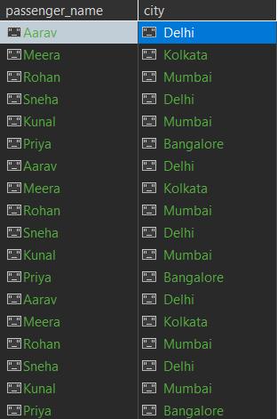
3.db.flights.find({ source: "Delhi" });
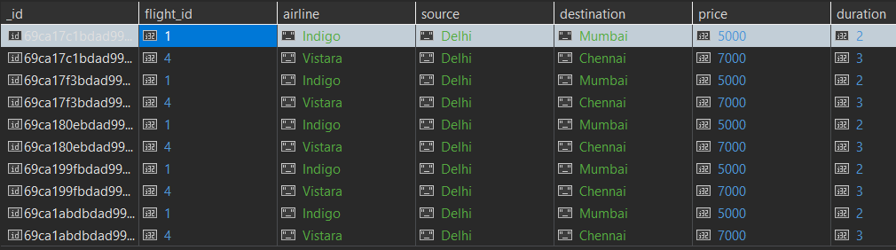
4. db.bookings.find({ seats: 1 });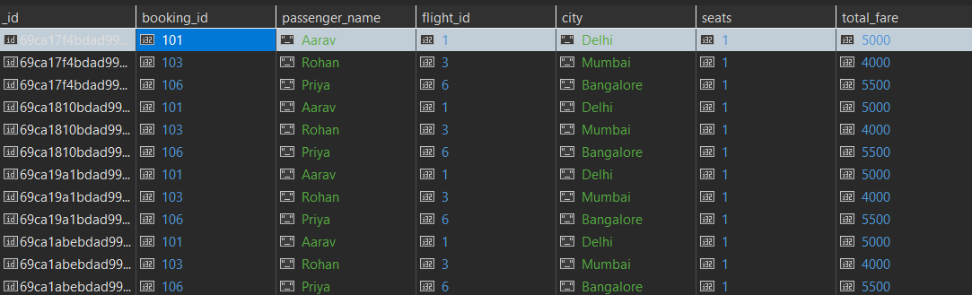
5.db.flights.find({}).sort({ price: 1 });
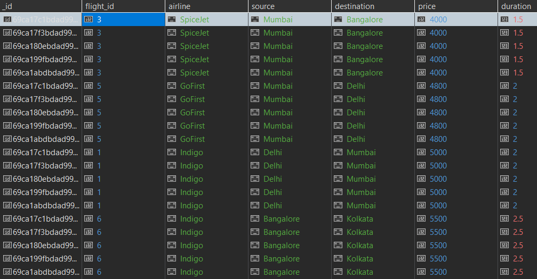


6.db.bookings.find({}).sort({ total_fare: -1 }).limit(2);
7.db.flights.find({ price: { $gt: 5000 } });
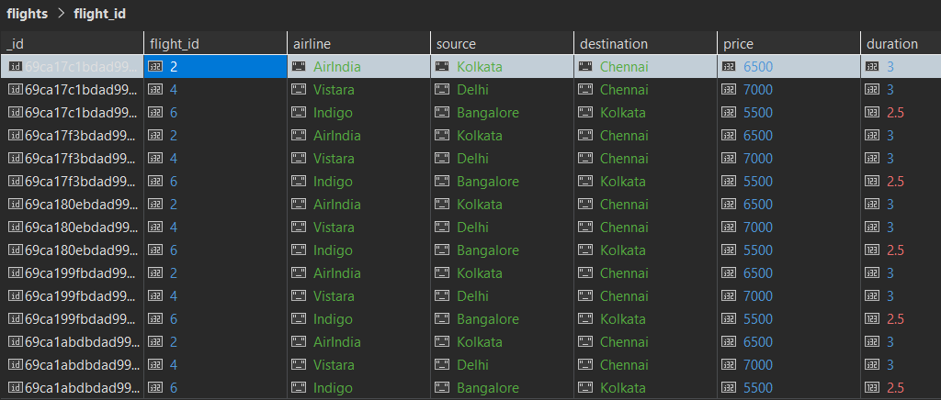

8.db.flights.find({ destination: { $ne: "Chennai" } });
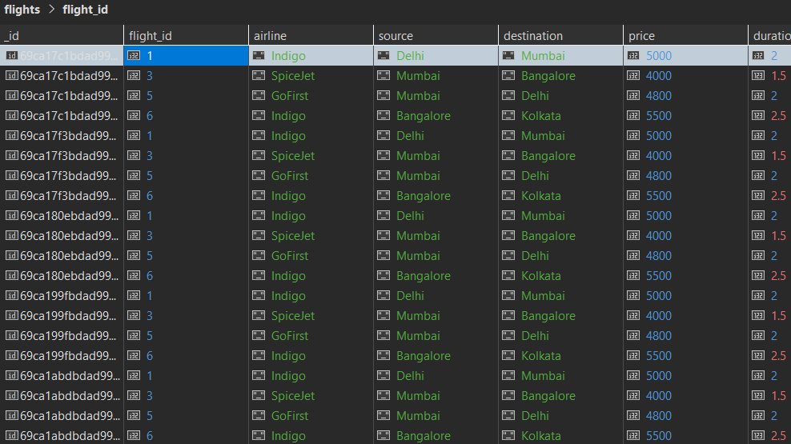
9.db.bookings.find({ seats: { $gte: 1, $lte: 2 } });
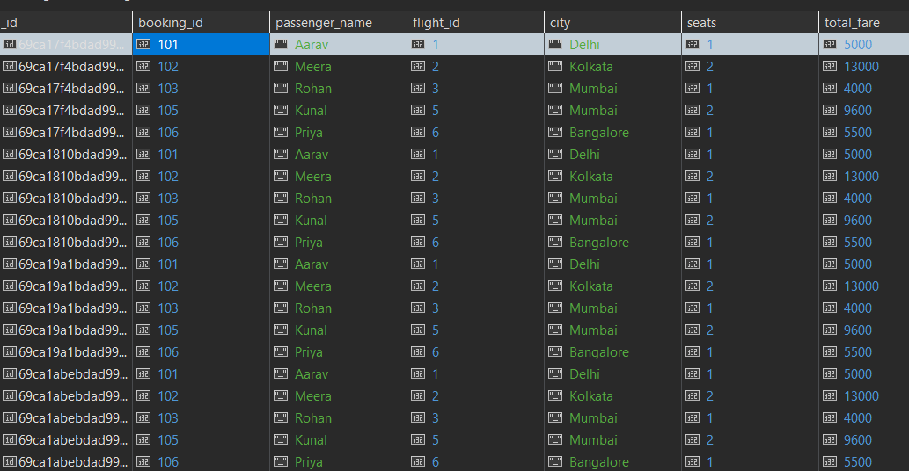

10. db.flights.updateMany(
{ airline: "Indigo" },
{ $inc: { price: 500 } }
)
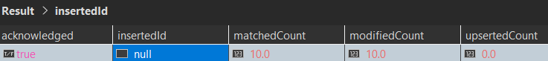
11. db.bookings.deleteMany({ seats: { $gt: 2 } })
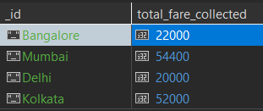

12. db.bookings.aggregate([
{
$group: {
_id: "$city",
total_fare_collected: { $sum: "$total_fare" }
}
}
]);
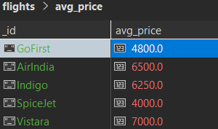

13. db.flights.aggregate([
{
$group: {
_id: "$airline",
avg_price: { $avg: "$price" }
}
}
]);
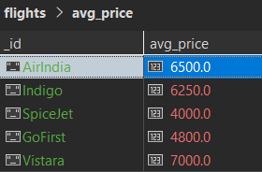
14. db.flights.aggregate([
{
$group: {
_id: "$airline",
avg_price: { $avg: "$price" }
}
},
{
$match: { avg_price: { $gt: 5500 } }
}
]);
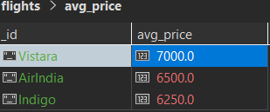

15. db.bookings.aggregate([
{
$group: {
_id: "$city",
max_total_fare: { $max: "$total_fare" }
}
}
]);
